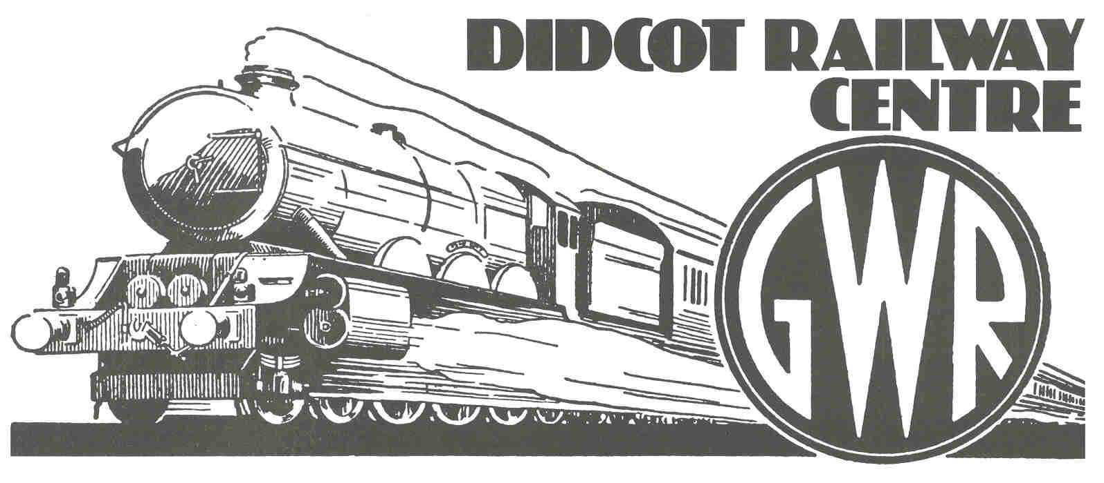
February 2006

BRUNEL’S BICENTENARY BIRTHDAY STEAMING

The world famous engineer Isambard Kingdom Brunel was born on 9 April 1806 and his birthday is being celebrated in style at Didcot Railway Centre exactly 200 years later on Sunday 9 April. Brunel was an eccentric genius who designed and built the Great Western Railway from Bristol to London to be the ‘finest in England’ using his unique broad gauge of 7 feet between the rails and it soon became known for its fast trains. However the problems caused for passengers and freight having to be transferred where its trains met the more usual standard gauge eventually led to its demise.

But at Didcot Railway Centre, almost half way between Bristol and London, the broad gauge lives on and visitors will be able to travel 1840s style behind the ‘Fire Fly’, a faithful replica of one of the original steam locomotives, starting from the Transfer Shed where freight once had to be transhipped onto standard gauge trains to the north. In contrast the connecting branch line train will be the Great Western diesel railcar No.22 dating from 1940. The Railway Centre includes the engine shed, now a living museum of the Great Western Railway with a fine collection of steam locomotives and many buildings and artefacts rescued from around the system by the volunteers of the Great Western Society.

Also this day sees the public opening of the new Science, Learning & Railways Centre with many interactive exhibits designed to interest and involve younger visitors in science and engineering.

This is one of many Brunel 200 events throughout the year celebrating the engineer’s many works. As well as railways he designed bridges and some of the earliest steamships.

Didcot Railway Centre will be open 10am to 5pm. The entrance is at Didcot Parkway rail station, served by First Great Western services and it is signed from the M4 (junction 13) and A34.

Editors: for further information please contact Jeanette Howse on Didcot (01235) 817200.

GREAT WESTERN SOCIETY : DIDCOT RAILWAY CENTRE : DIDCOT : OXFORDSHIRE : OX11 7NJ
Tel 01235 817200 : E-mail didrlyc@globalnet.co.uk : www.didcotrailwaycentre.org.uk

